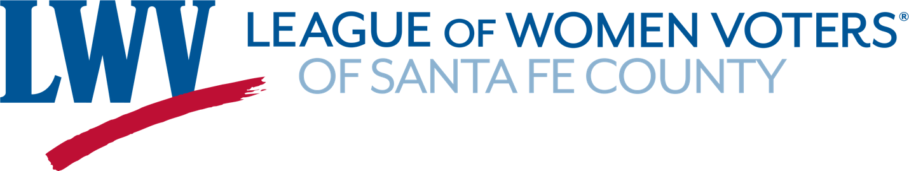
POLICY FOR PUBLICIZING NON-LEAGUE EVENTS
On occasion, organizations reach out to the LWVSFC asking to have their organizations’ event publicized to the LWVSFC membership and/or on our social media posts. The LWVNM has approved a policy for promotion of events outside of the League. The LWVSFC wishes to be in alignment with that policy. Therefore, we adopted the following policy.
The LWVSFC can agree to publicize an event of an outside organization as long as the following criteria are met:
- There is no encouragement to donate to that organization
- The goal of the event is to educate the public, to give input, and/or to hold decision makers accountable
- The event is strictly limited to advocacy on issues that the League supports and/or education of the public
- The organization and the event are strictly non-partisan, and
- The decision is approved by the Executive Committee of the Board of the LWVSFC

