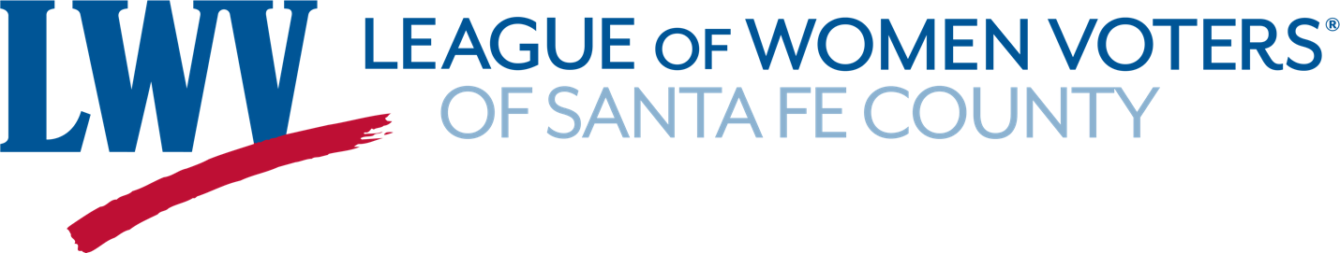

Diversity, Equity and Inclusion Policy

The League of Women Voters is an organization fully committed to diversity, equity and inclusion in principle and in practice in order to empower all voters to defend democracy
To achieve diversity the organization embraces the full participation of all individuals who comprise our society and who support the mission of the League of Women Voters and the US Constitution. Diversity means allowing no barriers on the basis of any dimension that can be used to separate one group of people from another.
To achieve equity the League pledges to provide opportunity for full understanding and participation in the democratic work of the League according to an individual’s capacity and interest.
To achieve inclusion the League pledges to afford individuals the opportunity to participate and invites and welcomes all interested members to contribute to the work of the League.
The League of Women Voters of Santa Fe County commits to work actively toward the individual and collective understanding of self-awareness and diverse perspectives and experiences by providing opportunities for diversity, equity and inclusion of all people.

Approved by the LWVSFC Board March 16, 2021.

